**2025 SOUTH AUSTRALIAN RURAL AMBASSADOR AWARD  
ENTRY FORM**

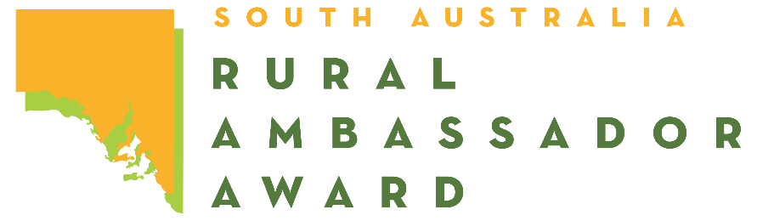

*Please complete this entry form and lodge it with the Secretary or Rural Ambassador Award Convenor   
of the Country Show Society that you wish to represent.*

Representing: Show Society  
From the: Association

Given Name: Surname:   
Preferred Name: Date of Birth: / /

Postal Address:

Town: Post Code:

Phone: Mobile:

Email:

I have read a copy of the 2025 Rural Ambassador Award entry criteria and agree to abide by the rules and regulations stated, including:

* I agree to represent my local show (if selected) at the association, and state final;
* I have not entered the Rural Ambassador Award at any other association this show season;
* I agree to provide a copy of my CV and an introductory letter for show society, association, and state final judging by the required dates;
* I am aged between 20 years and under 30 years as at the 1st of May 2025 (i.e., born between the 2nd of May 1995 and the 1st of May 2005 inclusively);
* As a state finalist I content for my name and contact details to be made available on the SA Country Shows website for show societies should they wish to contact me;
* I agree to my photo being taken, and used as detailed in the entry criteria;
* If selected as winner of my association, I agree to attend the state final conducted during the 2025 Royal Adelaide Show from 11:30am on Friday the 29th August (pre-show) to 10:00pm on Tuesday the 2nd of September 2025 (dates to be confirmed).
* If selected as state winner of the Rural Ambassador Award, to represent South Australia in the Agricultural Shows Australia National Finals in 2026 in Perth, date and location to be advised.

Signed: Date: / /