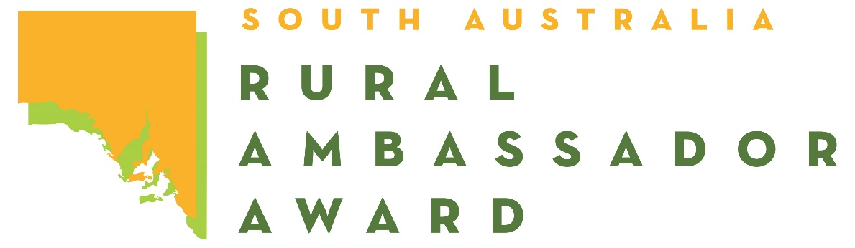

Dear SA Country Show Association and Show Secretaries,

Please find below the name and contact details for the 2024 South Australian Rural Ambassador State Finalists.

As outlined in the award criteria you are actively encouraged to please extend an invitation for them to attend the following events over the next 12 months:

1. Your local Show.

2. The Shows in your Show Association.

3. Your Show Association Annual General Meeting and Presentation Dinner/Night.

4. Judging of the following year’s Young Rural Ambassador Award finalists.

The availability of the ambassadors will depend on employment and other commitments.

Encouraging **all finalists** to remain involved in SA Country Shows is very important.

|  |  |  |  |
| --- | --- | --- | --- |
| Name: | Kayla Starkey | Postal: | PO Box 5, Mt Pleasant 5235 |
| Country Show: | Mt Pleasant | Email: | [hillviewstud@gmail.com](mailto:hillviewstud@gmail.com) |
| Association: | Central | Mobile: | 0421 328 590 |
| Name: | Lily Venning | Postal: | PO Box 505, Kimba SA 5641 |
| Country Show: | Kimba | Email: | [lily.venning03@outlook.com](mailto:lily.venning03@outlook.com) |
| Association: | Eyre Peninsula | Mobile: | 0455 888 494 |
| Name: | Samuel Doering | Postal: | 975 St kitts Road, Truro 5356 |
| Country Show: | Eudunda | Email: | [samueldoering13@gmail.com](mailto:samueldoering13@gmail.com) |
| Association: | Northern | Mobile: | 0477 972 630 |
| Name: | Braden Turner | Postal: | PO Box 181, Roseworthy 5371 |
| Country Show: | Gawler | Email: | [turnerbraden21@gmail.com](mailto:turnerbraden21@gmail.com) |
| Association: | Northern | Mobile: | 0427 056 307 |
| Name: | Nathaniel Modra | Postal: | 2255 Naracoorte Rd, Western Flat 5268 |
| Country Show: | Mundulla | Email: | [nathanielmodra@outlook.com](mailto:nathanielmodra@outlook.com) |
| Association: | South East & Border | Mobile: | 0428 082 949 |
| Name: | Cory O’Connor | Postal: | 87 Clarke St, Penola 5277 |
| Country Show: | Penola | Email: | [cory.oconnor556@schools.sa.edu.au](mailto:cory.oconnor556@schools.sa.edu.au) |
| Association: | South East & Border | Mobile: | 0478 131 733 |
| Name: | Henry Scott | Postal: | PO Box 215, Middleton 5213 |
| Country Show: | Port Elliot | Email: | [henry.scott@metos.com.au](mailto:henry.scott@metos.com.au) |
| Association: | Southern | Mobile: | 0406 146 819 |

Yours sincerely,

Jacqueline Francis

Youth Competitions Coordinator